SEC Form 4

**FORM 4**

Check this box if no longer subject to Section 16. Form 4 or Form 5 obligations may continue. *See* Instruction 1(b).



|  |  |  |  |  |  |
| --- | --- | --- | --- | --- | --- |
| **UNITED STATES SECURITIES AND EXCHANGE COMMISSION** |  |  |  |  |  |
| Washington, D.C. 20549 |  |  |  |  |  |
|  | OMB APPROVAL | | |  |
|  |  |  |
| **STATEMENT OF CHANGES IN BENEFICIAL OWNERSHIP** |  |  |  |  |  |
|  | OMB Number: | 3235-0287 |  |  |
|  | Estimated average burden | | |  |
|  |  |  |
| Filed pursuant to Section 16(a) of the Securities Exchange Act of 1934 |  | hours per response: | 0.5 |  |  |
|  |  |  |  |  |
|  |  |  |  |  |



or Section 30(h) of the Investment Company Act of 1940

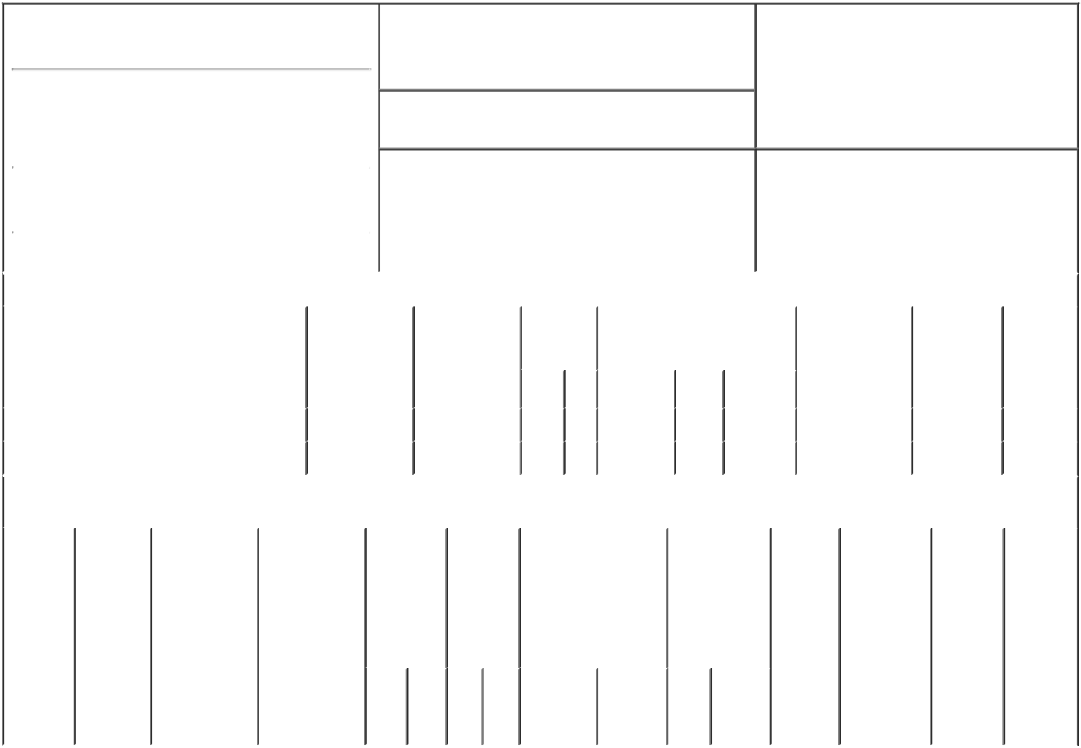

1. Name and Address of Reporting Person*

[BASSETT JOHN E III](http://www.sec.gov/cgi-bin/browse-edgar?action=getcompany&CIK=0001017057)

(Last) (First) (Middle)

BASSETT FURNITURE INDUSTRIES INC 3525 FAIRYSTONE PARK HWY

2. Issuer Name **and** Ticker or Trading Symbol

[BASSETT FURNITURE INDUSTRIES](http://www.sec.gov/cgi-bin/browse-edgar?action=getcompany&CIK=0000010329)

[INC [ BSET ]](http://www.sec.gov/cgi-bin/browse-edgar?action=getcompany&CIK=0000010329)

3. Date of Earliest Transaction (Month/Day/Year)

04/24/2018

1. Relationship of Reporting Person(s) to Issuer (Check all applicable)

|  |  |  |  |
| --- | --- | --- | --- |
|  | Director | 10% Owner |  |
| X | Officer (give title | Other (specify |  |
| below) | below) |  |
|  |  |

SVP, Wood

|  |  |  |  |  |  |  |  |  |  |  |  |  |  |  |  |  |  |  |  |  |  |  |  |  |  |  |  |
| --- | --- | --- | --- | --- | --- | --- | --- | --- | --- | --- | --- | --- | --- | --- | --- | --- | --- | --- | --- | --- | --- | --- | --- | --- | --- | --- | --- |
|  |  |  |  |  |  |  |  | 4. If Amendment, Date of Original Filed (Month/Day/Year) | | | | | | | |  | 6. Individual or Joint/Group Filing (Check Applicable | | | | | | | | | |  |
|  | (Street) | |  |  |  |  |  |  |  |  |  |  |  |  |  |  | Line) | | |  |  |  |  |  |  |  |  |
|  |  |  |  |  |  |  |  |  |  |  |  |  |  |  |  | X Form filed by One Reporting Person | | | | | | | | |  |
|  |  | BASSETT | | VA |  | 24055 |  |  |  |  |  |  |  |  |  |  |  |  |
|  |  |  |  |  |  |  |  |  |  |  |  |  |  |  |  | Form filed by More than One Reporting | | | | | | |  |
|  |  |  |  |  |  |  |  |  |  |  |  |  |  |  |  |  |  |  |  |  |
|  |  |  |  |  |  |  |  |  |  |  |  |  |  |  |  |  |  |  |  | Person | | |  |  |  |  |  |
|  |  | (City) |  | (State) | | (Zip) | |  |  |  |  |  |  |  |  |  |  |  |  |  |  |  |  |  |
|  |  |  |  |  |  |  |  |  |  |  |  |  |  |  |  |  |  |  |  |  |  |  |
|  |  |  |  |  |  | |  | | | | | | |  | | | |  |  | | |  |  |  |  |  |  |
|  |  |  |  |  | **Table I - Non-Derivative Securities Acquired, Disposed of, or Beneficially Owned** | | | | | | | | | | | | | | | | | |  |  |  |  |  |
|  |  | | | | |  |  | |  | |  |  |  |  | | | |  |  |  | |  |  |  |  |  |  |
|  | **1. Title of Security (Instr. 3)** | | | | | **2. Transaction** | | | **2A. Deemed** | | **3.** |  | **4. Securities Acquired (A) or** | | | | | | | **5. Amount of** | | | **6. Ownership** | | **7. Nature** | |  |
|  |  |  |  |  |  | **Date** | |  | **Execution Date,** | | **Transaction** | | **Disposed Of (D) (Instr. 3, 4 and 5)** | | | | | | | **Securities** | | | **Form: Direct** | | **of Indirect** | |  |
|  |  |  |  |  |  | **(Month/Day/Year)** | | | **if any** |  | **Code (Instr.** | |  |  |  |  |  |  |  | **Beneficially** | | | **(D) or Indirect** | | **Beneficial** | |  |
|  |  |  |  |  |  |  |  |  | **(Month/Day/Year)** | | **8)** |  |  |  |  |  |  |  |  | **Owned Following** | | | **(I) (Instr. 4)** | | **Ownership** | |  |
|  |  |  |  |  |  |  |  |  |  |  |  |  |  |  |  |  |  |  |  | **Reported** | | |  |  | **(Instr. 4)** | |  |
|  |  |  |  |  |  |  |  |  |  |  |  |  |  |  |  |  |  |  |  |  |  |  |
|  |  |  |  |  |  |  |  |  |  |  | **Code** | **V** | **Amount** | | **(A) or** | **Price** | | | | **Transaction(s)** | | |  |  |  |  |  |
|  |  |  |  |  |  |  |  |  |  |  | **(D)** | **(Instr. 3 and 4)** | | |  |  |  |  |  |
|  |  |  |  |  |  |  |  |  |  |  |  |  |  |  |  |  |  |  |  |  |  |  |  |
|  |  | | |  |  |  |  | |  |  |  |  |  |  |  |  | |  |  |  | |  |  |  |  |  |  |
|  | Common Stock | | |  |  | 04/24/2018 | | |  |  | G | V | 250(1) | | D | $29.25(2) | | |  | 38,429.3058(3) | | |  | D |  |  |  |
|  | Common Stock | | |  |  | 07/17/2018 | | |  |  | F |  | 490 |  | D |  | $26.3(4) | |  | 37,939.3058(3) | | |  | D |  |  |  |
|  |  |  |  |  | **Table II - Derivative Securities Acquired, Disposed of, or Beneficially Owned** | | | | | | | | | | | | | | | |  |  |  |  |  |  |  |
|  |  |  |  |  |  | **(e.g., puts, calls, warrants, options, convertible securities)** | | | | | | | | | | | | | |  |  |  |  |  |  |  |  |
|  |  | |  |  |  |  |  |  |  |  |  | | |  |  | |  |  |  | |  |  |  |  |  |  |  |
|  | **1. Title of** | | **2.** |  | **3. Transaction** | **3A. Deemed** | | **4.** |  | **5. Number** | **6. Date Exercisable and** | | | | **7. Title and** | |  | **8. Price of** | | | **9. Number of** | | **10.** | | **11. Nature** | |  |
|  | **Derivative** | | **Conversion** | | **Date** | **Execution Date,** | | **Transaction** | | **of** | **Expiration Date** | | | | **Amount of** | |  | **Derivative** | | | **derivative** | | **Ownership** | | **of Indirect** | |  |
|  | **Security** | | **or Exercise** | | **(Month/Day/Year)** | **if any** | | **Code (Instr.** | | **Derivative** | **(Month/Day/Year)** | | | | **Securities** | |  | **Security** | | | **Securities** | | **Form:** | | **Beneficial** | |  |
|  | **(Instr. 3)** | | **Price of** |  |  | **(Month/Day/Year)** | | **8)** |  | **Securities** |  |  |  |  | **Underlying** | |  | **(Instr. 5)** | | | **Beneficially** | | **Direct (D)** | | **Ownership** | |  |
|  |  |  | **Derivative** | |  |  |  |  |  | **Acquired** |  |  |  |  | **Derivative** | |  |  |  |  | **Owned** | | **or Indirect** | | **(Instr. 4)** | |  |
|  |  |  | **Security** |  |  |  |  |  |  | **(A) or** |  |  |  |  | **Security (Instr. 3** | | | | |  | **Following** | | **(I) (Instr. 4)** | |  |  |  |
|  |  |  |  |  |  |  |  |  |  | **Disposed** |  |  |  |  | **and 4)** |  |  |  |  |  | **Reported** | |  |  |  |  |  |
|  |  |  |  |  |  |  |  |  |  | **of (D)** |  |  |  |  |  |  |  |  |  |  | **Transaction(s)** | | | |  |  |  |
|  |  |  |  |  |  |  |  |  |  | **(Instr. 3, 4** |  |  |  |  |  |  |  |  |  |  | **(Instr. 4)** | |  |  |  |  |  |
|  |  |  |  |  |  |  |  |  |  | **and 5)** |  |  |  |  |  |  |  |  |  |  |  |  |  |  |  |  |  |
|  |  |  |  |  |  |  |  |  |  |  |  |  |  |  |  |  | |  |  |  |  |  |  |  |  |  |  |
|  |  |  |  |  |  |  |  |  |  |  |  |  |  |  |  | **Amount** | | | |  |  |  |  |  |  |  |  |
|  |  |  |  |  |  |  |  |  |  |  |  |  |  |  |  | **or** |  |  |  |  |  |  |  |  |  |  |  |
|  |  |  |  |  |  |  |  |  |  |  |  |  |  |  |  | **Number** | | | |  |  |  |  |  |  |  |  |
|  |  |  |  |  |  |  |  |  |  |  | **Date** |  | **Expiration** | |  | **of** |  |  |  |  |  |  |  |  |  |  |  |
|  |  |  |  |  |  |  |  | **Code** | **V** | **(A) (D)** | **Exercisable** | | **Date** | | **Title** | **Shares** | | | |  |  |  |  |  |  |  |  |
|  |  | | | | |  |  |  |  |  |  |  |  |  |  |  |  |  |  |  |  |  |  |  |  |  |  |
|  | **Explanation of Responses:** | | | | |  |  |  |  |  |  |  |  |  |  |  |  |  |  |  |  |  |  |  |  |  |  |
|  | 1. Bona fide gift. | | |  |  |  |  |  |  |  |  |  |  |  |  |  |  |  |  |  |  |  |  |  |  |  |  |
|  | 2. Price of Bassett Furniture Industries Stock at the close of business 04/24/2018. | | | | | | | | |  |  |  |  |  |  |  |  |  |  |  |  |  |  |  |  |  |  |
|  | 3. Includes shares acquired under the 2000 and 2017 Employee Stock Purchase Plans in transactions exempt under Rule 16-3(A). | | | | | | | | | | | | | |  |  |  |  |  |  |  |  |  |  |  |  |  |
|  | 4. Price of Bassett Furniture Industries Stock at the close of business 07/17/18. | | | | | | | |  |  |  |  |  |  |  |  |  |  |  |  |  |  |  |  |  |  |  |
|  |  |  |  |  |  |  |  |  |  |  |  |  |  | /s/ John E. Bassett III | | | | |  |  | 07/18/2018 | | | |  |  |  |
|  |  |  |  |  |  |  |  |  |  |  |  |  |  |  | | | | |  | |  |  |  |  |  |  |  |
|  |  |  |  |  |  |  |  |  |  |  |  |  |  | ** Signature of Reporting Person | | | | | | | Date | |  |  |  |  |  |
|  | Reminder: Report on a separate line for each class of securities beneficially owned directly or indirectly. | | | | | | | | | | | |  |  |  |  |  |  |  |  |  |  |  |  |  |  |  |
|  | * If the form is filed by more than one reporting person, *see* Instruction 4 (b)(v). | | | | | | | | |  |  |  |  |  |  |  |  |  |  |  |  |  |  |  |  |  |  |

* Intentional misstatements or omissions of facts constitute Federal Criminal Violations *See* 18 U.S.C. 1001 and 15 U.S.C. 78ff(a). Note: File three copies of this Form, one of which must be manually signed. If space is insufficient, *see* Instruction 6 for procedure.

**Persons who respond to the collection of information contained in this form are not required to respond unless the form displays a currently valid OMB Number.**