SEC Form 4

FORM 4

Check this box if no longer subject to Section 16. Form 4 or Form 5 obligations may continue. See Instruction 1(b).

UNITED STATES SECURITIES AND EXCHANGE COMMISSION
Washington, D.C. 20549
 |  | OMB APPROVAL
STATEMENT OF CHANGES IN BENEFICIAL OWNERSHIP
 |  | OMB Number: | 3235-0287
 |  | Estimated average burden
Filed pursuant to Section 16(a) of the Securities Exchange Act of 1934 |  | hours per response: | 0.5
or Section 30(h) of the Investment Company Act of 1940
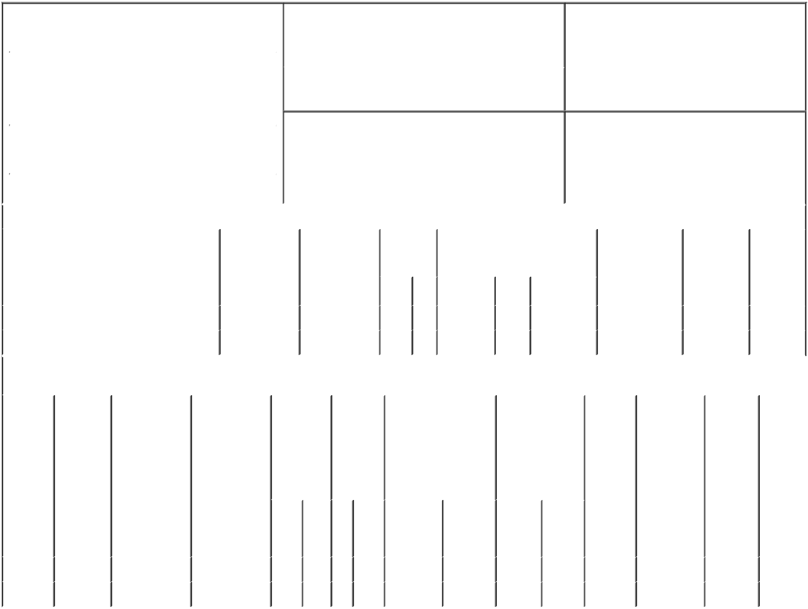

1. Name and Address of Reporting Person* |  |  |  |  |  |  | 2. Issuer Name and Ticker or Trading Symbol
 | Baker David C |  |  |  |  |  | BASSETT FURNITURE INDUSTRIES
 |  |  |  |  |  |  | INC [ BSET ]
 | (Last) | (First) |  | (Middle)
 |  |  |  |  |  |  | 3. Date of Earliest Transaction (Month/Day/Year)
 | P.O. BOX 626
 |  |  |  |  | 01/25/2017

3525 FAIRYSTONE PARK HWY

- Relationship of Reporting Person(s) to Issuer (Check all applicable)

 | Director | 10% Owner
X | Officer (give title | Other (specify
 | below) | below)

SVP, Corporate Retail

 |  |  |  |  |  |  |  | 4. If Amendment, Date of Original Filed (Month/Day/Year) |  |  |  |  |  |  | 6. Individual or Joint/Group Filing (Check Applicable
 | (Street) |  |  |  |  |  |  |  |  |  |  |  |  |  | Line)
 |  |  |  |  |  |  |  |  |  |  |  |  |  |  | X Form filed by One Reporting Person
 |  | BASSETT |  | VA |  | 24055
 |  |  |  |  |  |  |  |  |  |  |  |  |  |  |  |  |  | Form filed by More than One Reporting
 |  |  |  |  |  |  |  |  |  |  |  |  |  |  |  |  |  | Person
 |  | (City) |  | (State) |  | (Zip)
 |  |  |  |  | Table I - Non-Derivative Securities Acquired, Disposed of, or Beneficially Owned
 | 1. Title of Security (Instr. 3) |  |  |  |  | 2. Transaction |  |  | 2A. Deemed |  | 3. | 4. Securities Acquired (A) or |  |  |  |  |  | 5. Amount of |  | 6. Ownership |  | 7. Nature
 |  |  |  |  |  | Date |  |  | Execution Date, |  | Transaction | Disposed Of (D) (Instr. 3, 4 and 5) |  |  |  |  |  | Securities |  | Form: Direct |  | of Indirect
 |  |  |  |  |  | (Month/Day/Year) |  |  | if any |  | Code (Instr. |  |  |  |  |  |  | Beneficially |  | (D) or Indirect |  | Beneficial
 |  |  |  |  |  |  |  |  | (Month/Day/Year) |  | 8) |  |  |  |  |  |  | Owned Following |  | (I) (Instr. 4) |  | Ownership
 |  |  |  |  |  |  |  |  |  |  |  |  |  |  |  |  |  | Reported |  |  |  | (Instr. 4)
 |  |  |  |  |  |  |  |  |  |  | Code V | Amount | (A) or | Price |  |  |  | Transaction(s)
 |  |  |  |  |  |  |  |  |  |  |  |  | (D) |  |  |  |  | (Instr. 3 and 4)
 | Common |  |  |  |  | 01/25/2017 |  |  |  |  | M | 6,000 | A |  | $14.73⁽³⁾ |  | 28,766.1414⁽¹⁾ |  |  |  | D
 | Common |  |  |  |  | 01/25/2017 |  |  |  |  | S | 4,000 | D | $30.4291⁽⁴⁾ 24,766.1414⁽¹⁾ |  |  |  |  |  |  | D
 |  |  |  |  | Table II - Derivative Securities Acquired, Disposed of, or Beneficially Owned
 |  |  |  |  |  | (e.g., puts, calls, warrants, options, convertible securities)
 | 1. Title of |  | 2. |  | 3. Transaction | 3A. Deemed | 4. |  |  | 5. Number | 6. Date Exercisable and |  | 7. Title and |  |  |  | 8. Price of |  | 9. Number of |  | 10. | 11. Nature
 | Derivative |  | Conversion |  | Date | Execution Date, | Transaction |  |  | of | Expiration Date |  | Amount of |  |  |  | Derivative |  | derivative |  | Ownership | of Indirect
 | Security |  | or Exercise |  | (Month/Day/Year) | if any | Code (Instr. |  |  | Derivative | (Month/Day/Year) |  | Securities |  |  |  | Security |  | Securities |  | Form: | Beneficial
 | (Instr. 3) |  | Price of |  |  | (Month/Day/Year) | 8) |  |  | Securities |  |  | Underlying |  |  |  | (Instr. 5) |  | Beneficially |  | Direct (D) | Ownership
 |  |  | Derivative |  |  |  |  |  |  | Acquired |  |  | Derivative Security |  |  |  |  |  | Owned |  | or Indirect | (Instr. 4)
 |  |  | Security |  |  |  |  |  |  | (A) or |  |  | (Instr. 3 and 4) |  |  |  |  |  | Following |  | (I) (Instr. 4)
 |  |  |  |  |  |  |  |  |  | Disposed |  |  |  |  |  |  |  |  | Reported
 |  |  |  |  |  |  |  |  |  | of (D) |  |  |  |  |  |  |  |  | Transaction(s)
 |  |  |  |  |  |  |  |  |  | (Instr. 3, 4 |  |  |  |  |  |  |  |  | (Instr. 4)
 |  |  |  |  |  |  |  |  |  | and 5)
 |  |  |  |  |  |  |  |  |  |  |  |  |  |  | Amount
 |  |  |  |  |  |  |  |  |  |  |  |  |  |  | or
 |  |  |  |  |  |  |  |  |  |  |  |  |  |  | Number
 |  |  |  |  |  |  |  |  |  |  | Date | Expiration |  |  | of
 |  |  |  |  |  |  | Code |  | V | (A) (D) | Exercisable | Date | Title |  | Shares
 | Option⁽²⁾ |  | $14.73 |  | 01/25/2017 |  |  | M |  | 5,000 | 04/20/2008 | 04/19/2017 | Common |  | 5,000 |  | $14.73 |  | 0 |  | D
 | Option⁽²⁾ |  | $14.73 |  | 01/25/2017 |  |  | M |  | 1,000 | 04/20/2009 | 04/19/2017 | Common |  | 1,000 |  | $14.73 |  | 4,000 |  | D
 | Explanation of Responses:

- Includes shares acquired under the 2000 Employee Stock Purchase Plan in transactions exempt under Rule 16-3(A)

- Granted under the 1997 Employee Stock Plan which is Rule 16b-3 Plan.

- Corresponds to the exercise price of options.

- Price is weighted average of multiple trades ranging from $30.28 to $30.55 and reporting person undertakes to provide upon request to SEC staff, the issuer or security holder of the issuer, full information regarding the number of shares and prices at which the transaction was effected.

Dave Baker |  | 01/27/2017
** Signature of Reporting Person |  | Date

Reminder: Report on a separate line for each class of securities beneficially owned directly or indirectly.

* If the form is filed by more than one reporting person, see Instruction 4 (b)(v).

- Intentional misstatements or omissions of facts constitute Federal Criminal Violations See 18 U.S.C. 1001 and 15 U.S.C. 78ff(a). Note: File three copies of this Form, one of which must be manually signed. If space is insufficient, see Instruction 6 for procedure.
Persons who respond to the collection of information contained in this form are not required to respond unless the form displays a currently valid OMB Number.

